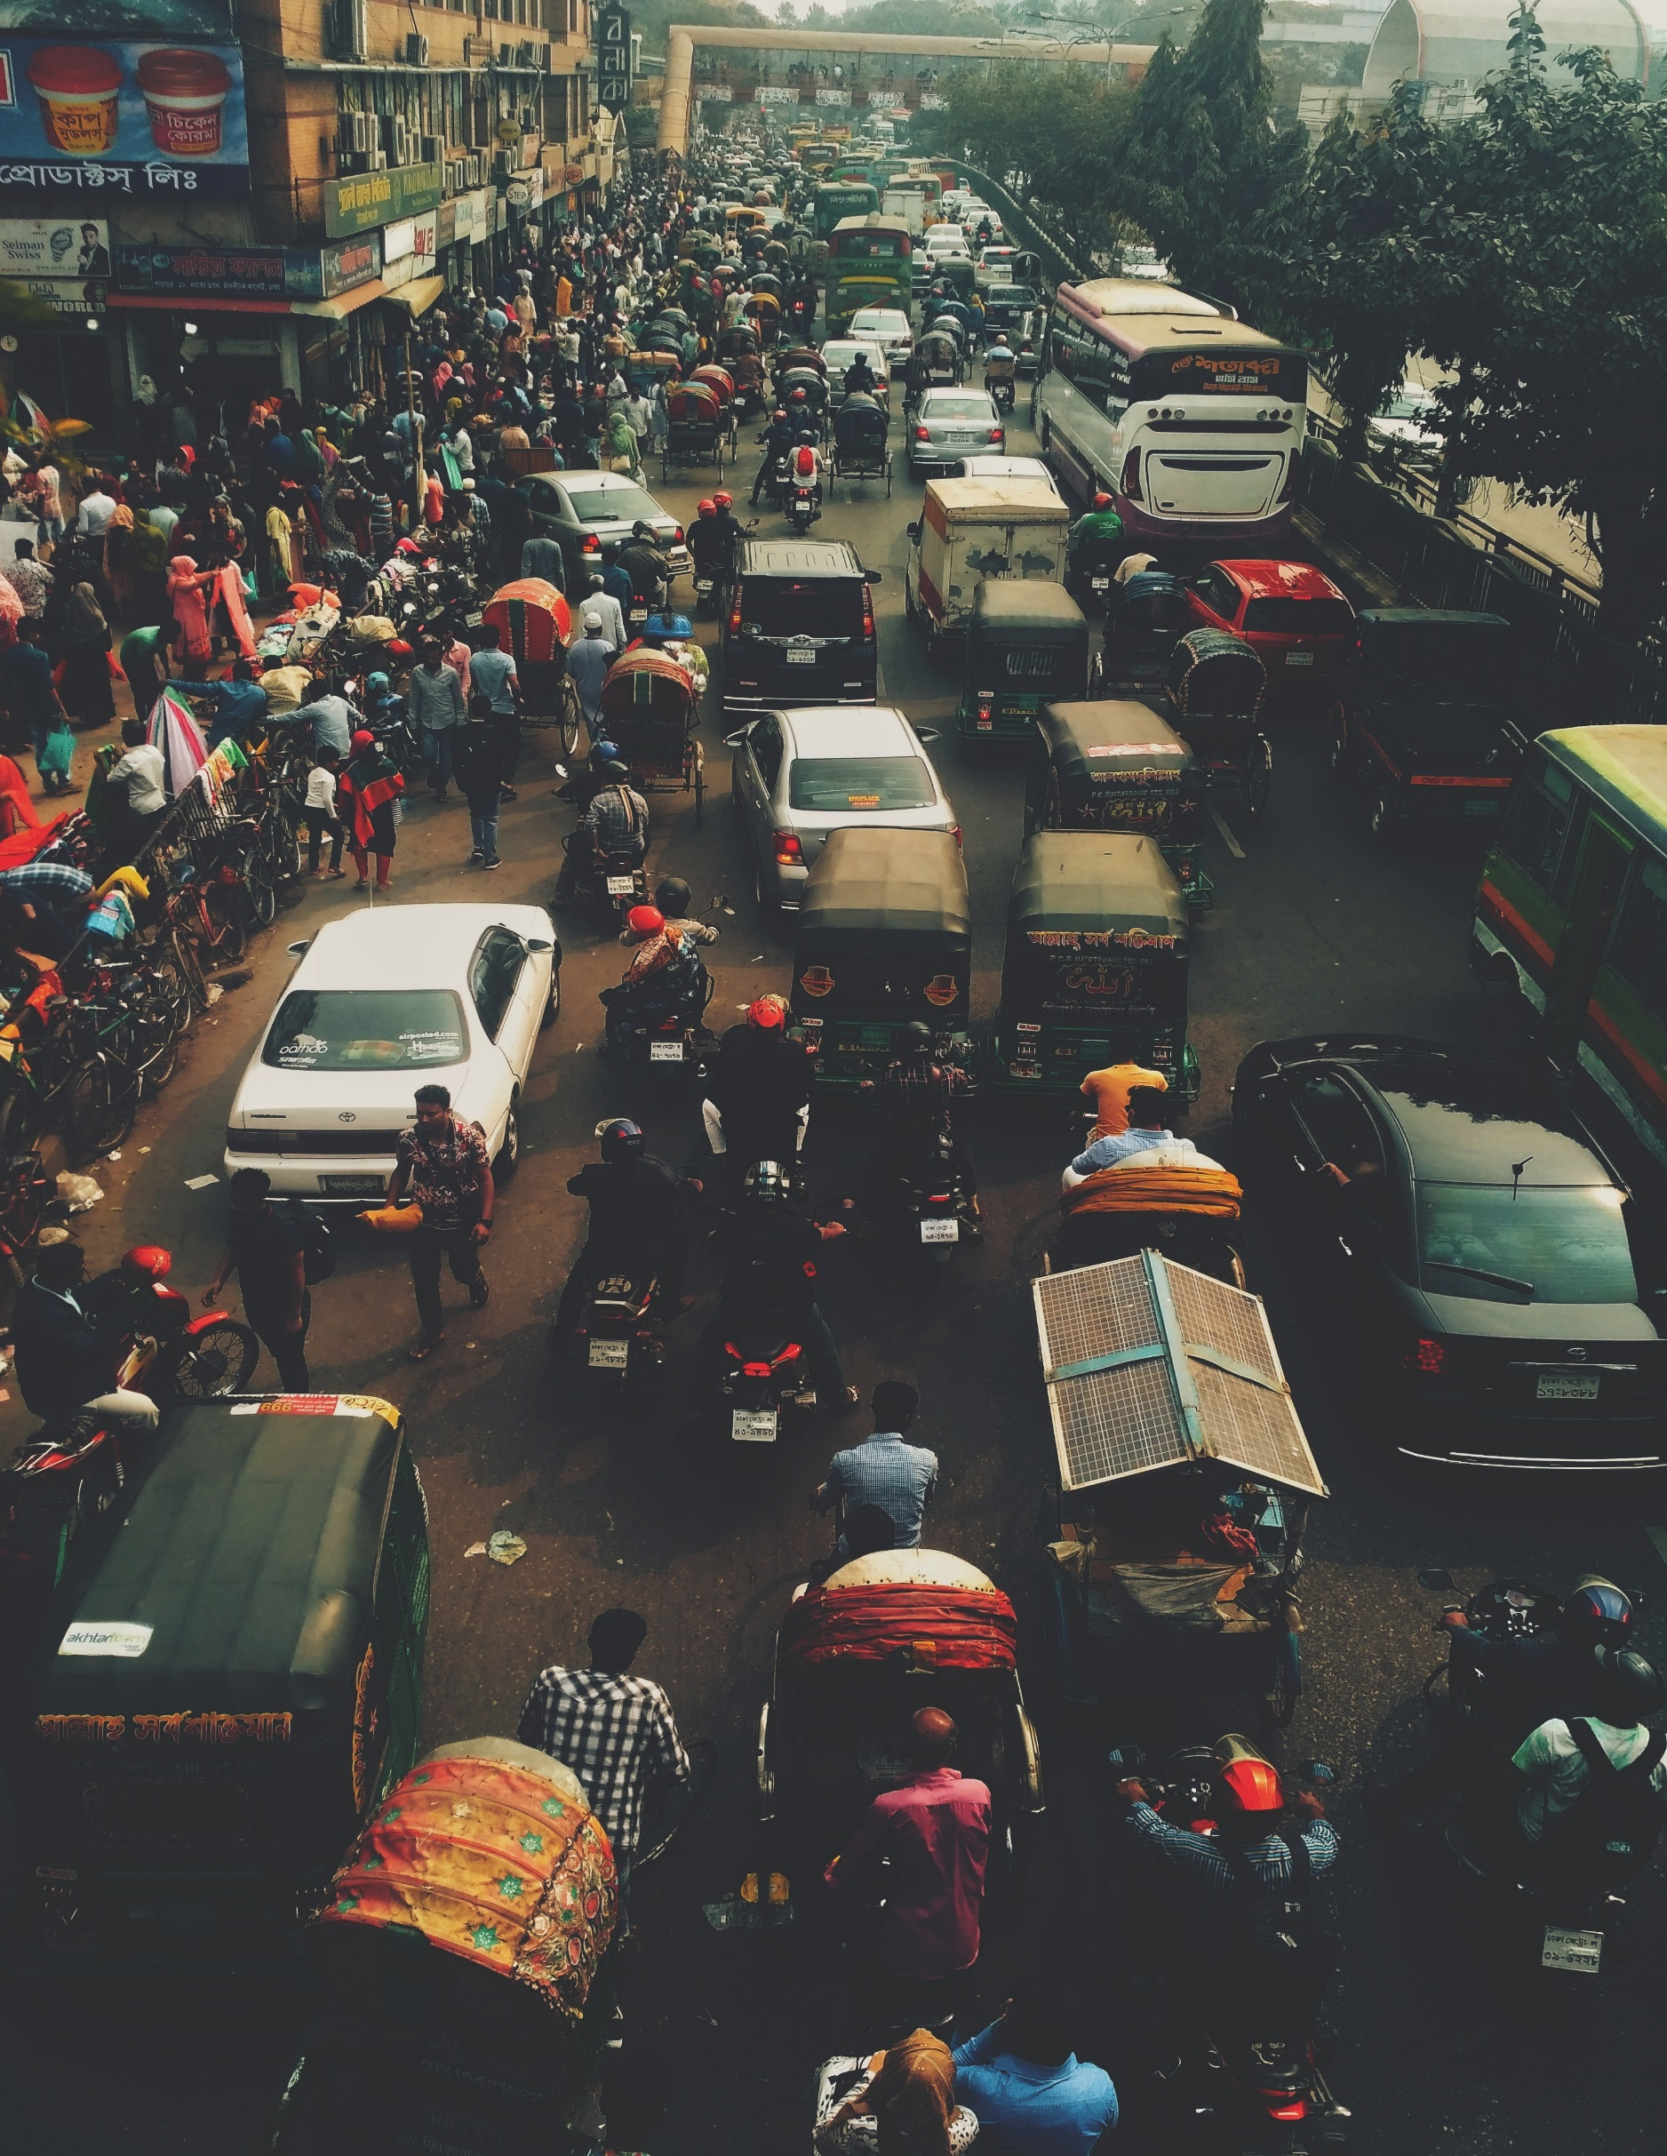­

**Vehicle Monitoring**

**System**



**Project Name: Vehicle Monitoring System**

Group Member:

|  |  |  |  |
| --- | --- | --- | --- |
| ID | Name | Email | Phone Number |
| 16-33047-3 | Iqbal, Md.Ahasan | [ahasaniqbal97@gmail.com](mailto:ahasaniqbal97@gmail.com) | 01812791998 |
| 18-36449-1 | Borno, MD.Sirajuddin | [bornoahmed2@gmail.com](mailto:bornoahmed2@gmail.com) | 01704992725 |
| 18-37994-2 | Arif Ahmed | [aimzarifj123@gmail.com](mailto:aimzarifj123@gmail.com) | 01741768368 |
| 18-38045-2 | Sohelee Sen | [sohelee.hridy97@gmail.com](mailto:sohelee.hridy97@gmail.com) | 01738270273 |

**1. Introduction**

1.1 Purpose –

Road accidents in Bangladesh have reached epidemic levels, with newspaper headlines reporting casualties on a daily basis. Road safety is on of greatest issue of our country. Our system can prevent the problem.

1.2 Document Convention –

text format: times new roman; font size :11;

1.3 Project Scope –

The scope of this project is to study and design the system will cover a vehicles lifetime track record. When a customer goes to buy a car or motorbike s/he can make sure that the product is authentic and till now all kinds of taxes have been paid. vehicle is using parking in wrong way it can notify the authority and the driver also.

1.4 References –

1. [https://bsp.brta.gov.bd/vehicleRegistration;jsessionid=BAF090C12A2271425BD3CD96C78559E6.server4?lan=en**l**](https://bsp.brta.gov.bd/vehicleRegistration;jsessionid=BAF090C12A2271425BD3CD96C78559E6.server4?lan=enl)

2.

<https://krazytech.com/projects/sample-software-requirements-specificationsrs-report-airline-database>

**2. Overall Description**

2.1 Productive perspective –

Objective: First automate the vehicle selling and its enlistment to BRTA. Who is purchasing the vehicle checking if that individual is qualified to purchase the vehicle. Purchaser must show driving permit. At that point while the vehicle is running out and about continually checking if its obeying with the traffic rules or not. With advanced tag digital license plate and some other equipment our system will be able check the vehicle progressively. Along these lines our streets will be increasingly sheltered. At that point system will also monitor its parking records.

2.2 User classes and characteristics –

|  |  |
| --- | --- |
| User Class | Characteristics |
| Vehicle Seller | To ensure all of his vehicles are listed on govt. list and when selling vehicle seller must show buyer that all the paper for vehicle are genuine . |
| Vehicle Owner | To checking vehicle status |
| BRTA officer | To get notification about vehicle on road and tax information. |
| Parking manager | To check vehicles parking status. |

2.3 Operating Environment –

This is going to be a web based system and will be accessible from Mac os or Windows. For Windows version should be windows 7 or higher. This system for BRTA so this is only for Bangladesh.

2.4 Design and implementation constraints –

To design this system there’s some option in languages. Like for database PHP can be used and for designing HTML, CSS can be used. Also Python is a good option.

**3. System Features**

3.1 Description of feature –

First automate the vehicle selling and its enlistment to BRTA. Who is purchasing the vehicle checking if that individual is qualified to purchase the vehicle. Purchaser must show driving permit. At that point while the vehicle is running out and about continually checking if its obeying with the traffic rules or not. With advanced tag digital license plate and some other equipment our system will be able check the vehicle progressively. Along these lines our streets will be increasingly sheltered. At that point system will also monitor its parking records.

3.2 Functional requirements –

|  |
| --- |
| Functional Requirements Description |
| the system will check if the car is available |
| the system will show different types of engine |
| the system will check if the buyer is eligible to purchase a car |
| if the buyer is eligible then when checking out the buyer will ask for buyer's credit card information |
| buyer's will enter his information to the system |
| the system will check for if the amount is available is buyer's account |
| if everything is correct then the system will let user buy car |
| a |
| The system shall verify the driving license and determine to which kind of user it corresponds, i.e. valid, privileged, car owner or invalid. |
| The system shall allow to start up the car only if the driving license of a valid user has been inserted in the slot |
| If there is an attempt to start up the car, the system shall explicitly ask for a valid driving license if no driving license has been inserted in the slot. |
| The system shall inform the user whether the inserted driving license is invalid or corresponds to an invalid user |
| Once the car has been started up, the driving license can be removed at any time |
| If the car is turned off and a driving license is in the slot, the system should inform the user that a driving license remains in the slot |
| The system only allows Bangladeshi driving licenses to be registered as valid. |
| In order for a privileged user to add or remove valid users, the driving license of the privileged user should remain inserted in the slot during the whole procedure. |
| In order for the car owner to manage any kind of user, the driving license of the car owner should remain inserted in the slot during the whole procedure. |
| The system shall copy the newly added user’s license chip information to the car’s user database. |
| In order to add a valid or privileged user to the system, the driving license of the user to be added is needed |
| a |
| System shall be able to detect accurate speed of a vehicle using speed metre and |
| System shall be able to detect if vehicle is maintaining signals using intelligent traffic monitoring algorithm |
| System shall be able to detect if vehicle is going through right route using motion detector and direction |
| System shall be able to Scan number plate using digital number plate reader |
| System shall be able to Take photograph of driver using CCTV camera |
| System shall be able to Send notification to associated Operator if any kind of rule is broken |
| System shall be able to Add fine to vehicle owner profile |
| System shall be able to Disable vehicle road permit if owner breaks rule numbers of time |
| a |
| the customer able to enter any parking area with digital number plate associated with system |
| Gates and blockers shall be integrated with smart identification technologies. |
| The customer shall be able to use parking management system which is integrated with Access control systems like Automatic gates, barrier controls, ticketing systems. |
| The parking management shall be able to regulate & monitor the parking facility requirements, designed to manage the car parking slots & provide useful reports and information to the developer |
| The access control shall be implemented with both open-end credit readers and biometric readers and similarly the surveillance are often upgraded |
| The Ticketing System shall be programed to the clients parking policies and integrated with the ticketing dispenser machines and Payment systems. |
| Security of vehicle shall be easy with CCTV and trackable number plates. |

3.3 User Stories (user requirements) –

|  |  |
| --- | --- |
| **Application** | **Use case** |
| Private Vehicle Monitoring System | 1. **Can login** 2. **Can update Profile** 3. **Tax** 4. Insurance 5. fitness papers 6. Vehicle registration 7. Can add credit card 8. Reports 9. Buy car 10. New registration 11. Renew License 12. Reports 13. Disable Driving license (optional) 14. Monitor Speed 15. Monitor Signals 16. Monitor route 17. Overtaking Other vehicle 18. Scan number plate 19. Take photograph of driver 20. Send notification to associated Operator 21. Add fine (optional) 22. Disable vehicle road permit(optional) 23. Automated Number Plate Recognition (ANPR) 24. Automated Parking Access 25. Parking Management 26. Security Analysis 27. Automated Ticketing |

|  |  |  |
| --- | --- | --- |
| **Application** | **Use case** | **Corresponding user story** |
|  | Add tax | As a user, I want to pay tax for buy a vehicle. |
|  | Insurance | As a user, I want to buy insurance before buying a vehicle. |
|  | Fitness Paper | As a user, I want to check fitness paper for buy a vehicle. |
|  | Can add credit card | As a user, I want to add credit card for buy a vehicle. |
|  |  |  |
| Private Vehicle Monitoring System | can login | Marchant ,Vehicle owner ,BRTA and Traffic officer shall be able login |
|  | Update Profile | User shall be able to update their profile |
|  | New Registration | As a user, I want to register for driving license so that I can drive vehicles. |
|  | Renew License | As a customer, I want to renew my license for future driving processes. |
|  | Reports | As a user, I want to keep reports so that I can view my driving records and check penalty or disqualifications. |
|  | Disable Driving license (optional) | As a disable user, I want to get license so that I can drive my own . |
|  | Monitor Speed | System shall be able to detect accurate speed of a vehicle |
|  | Monitor Signals | System shall be able to detect if vehicle is maintaining signals |
|  | Monitor route | System shall be able to detect if vehicle is going through right route |
|  | Overtaking Other vehicle | System shall be able to detect if vehicle is overtaking other vehicle in aggressive way |
|  | Scan number plate | System shall be able to Scan number plate |
|  | Take photograph of driver | System shall be able to Take photograph of driver |
|  | Send notification to associated Operator | System shall be able to Send notification to associated Operator |
|  | Add fine | System shall be able to Add fine |
|  | Disable vehicle road permit | System shall be able to Disable vehicle road permit |
|  | Automated Parking Access | As a user, I want parking access so that I can park my vehicle. |
|  | Parking Management | As a Parking authority, I want parking management details to regulate and monitor the parking facility requirements and manage the car parking slots. |
|  | Security Analysis | As a vehicle owner, I need security for creating a robust and secured parking solution. |
|  | Automated Ticketing | As a client, I need ticketing system for getting smooth payment system. |

**4. External Interface Requirements**

4.1 User interface

Prototypes : <https://github.com/Born0/Software-Requirement-Engineering/blob/master/SRE(Traffic).xd>

Log in:

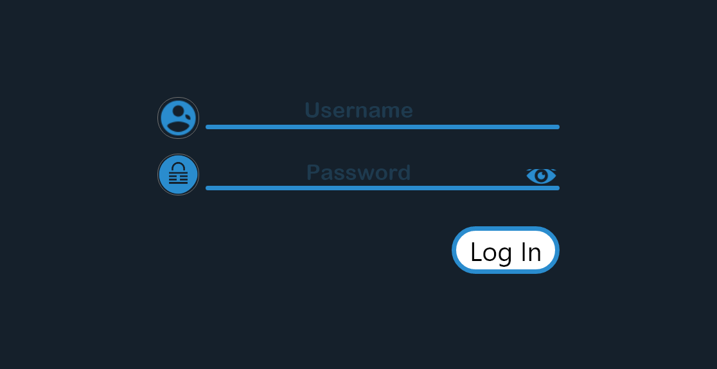

Marchant:

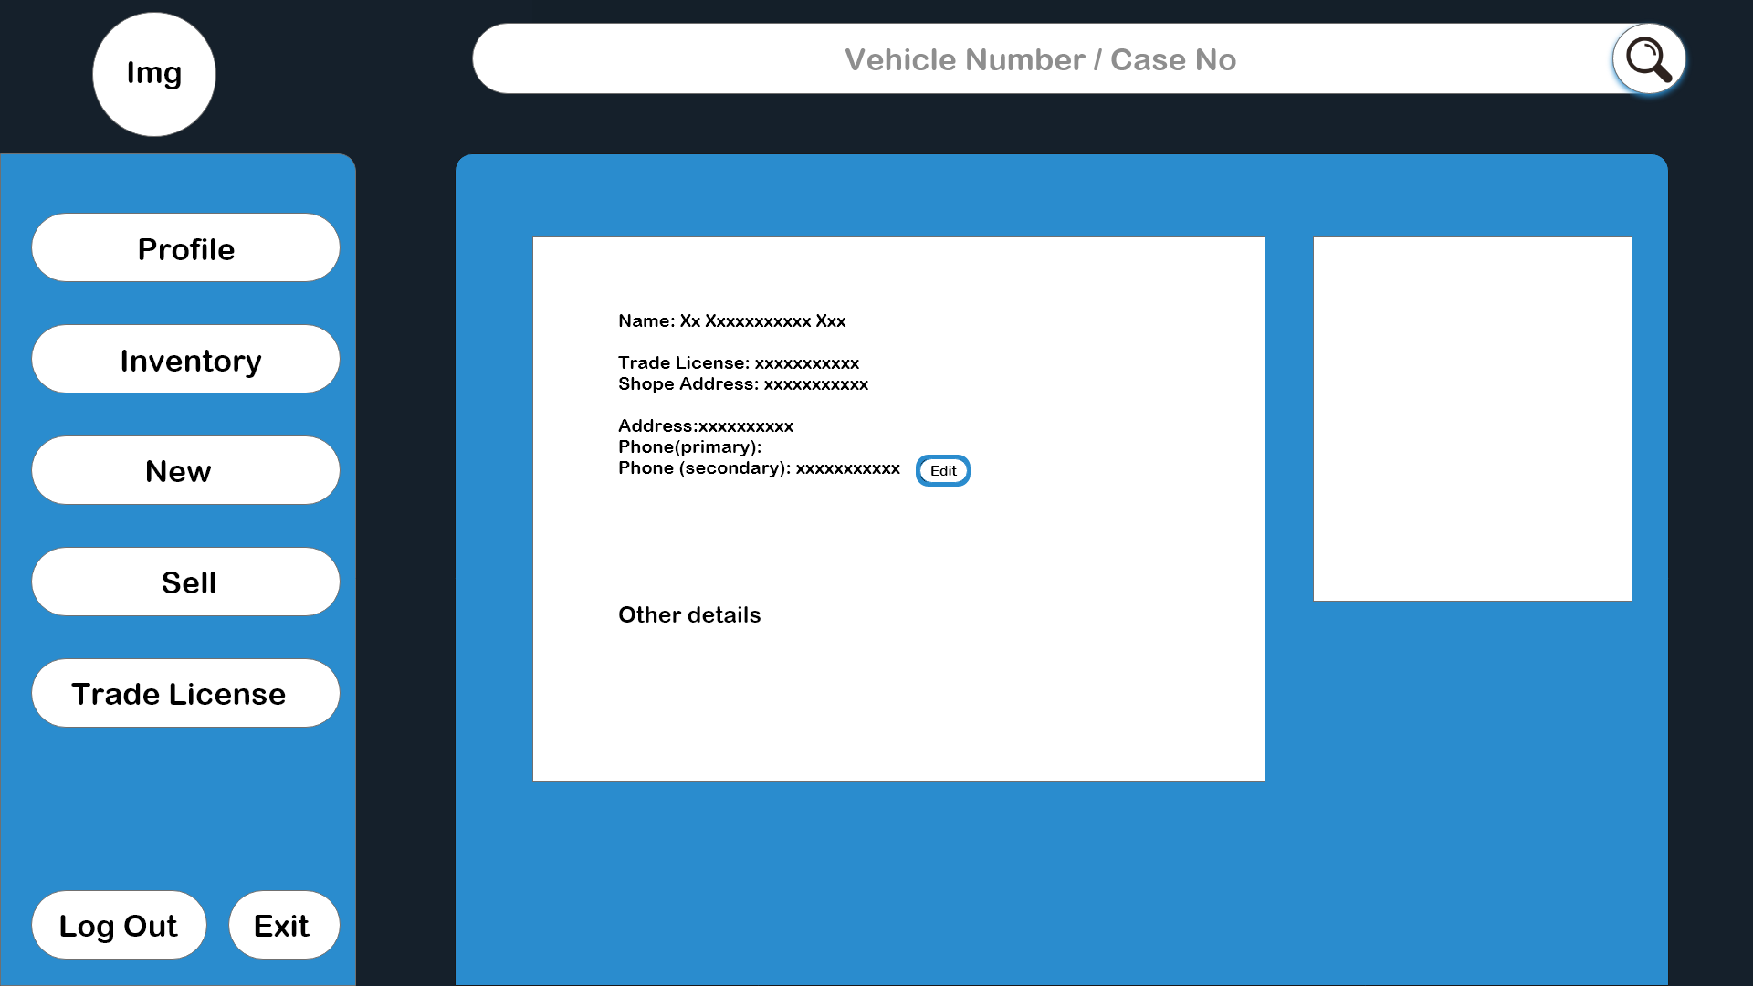

Details: Marchant’s Profile

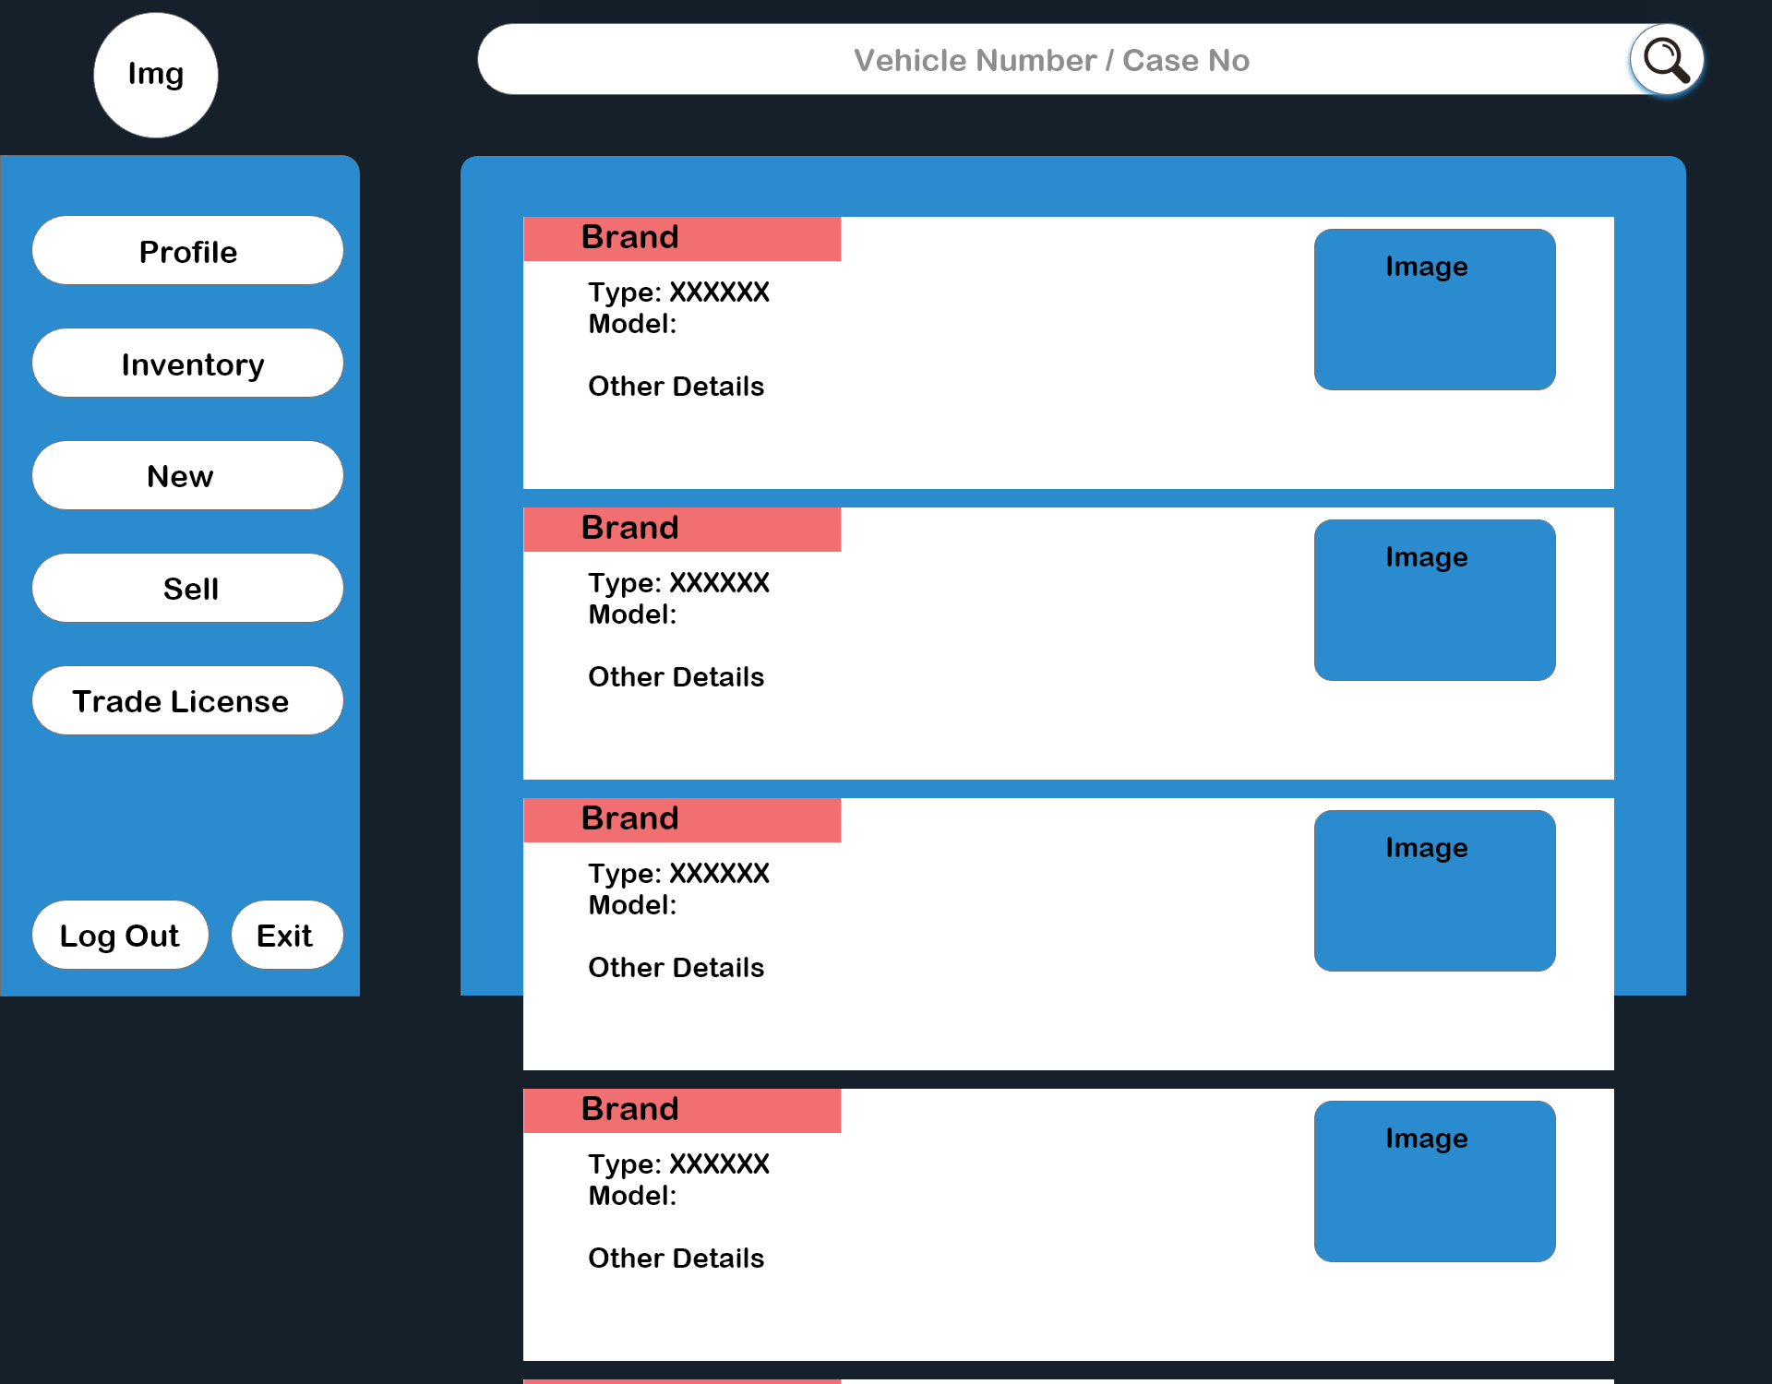

Details: Inventory

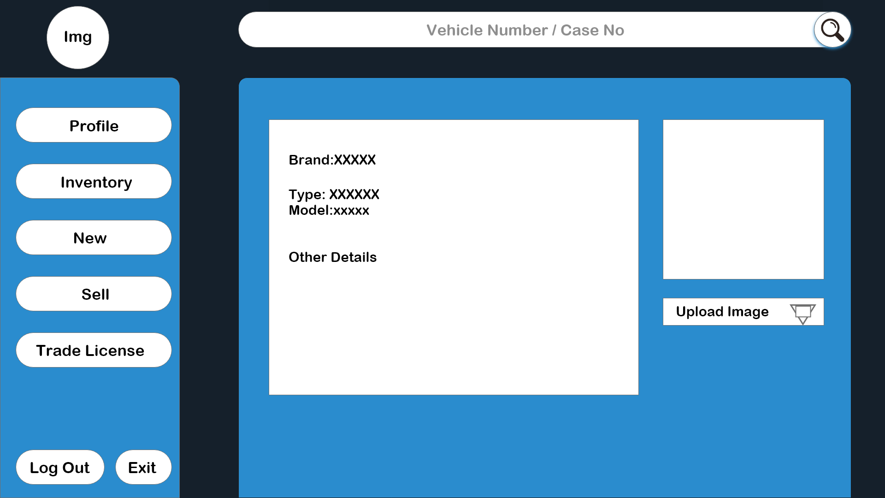

Details: Add new Product

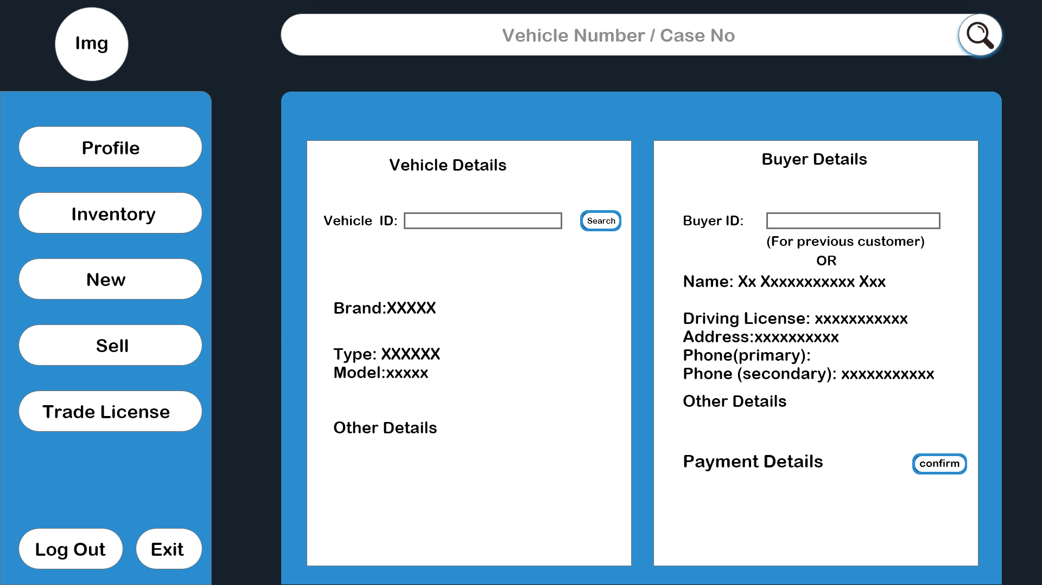

Details: Sell a Product

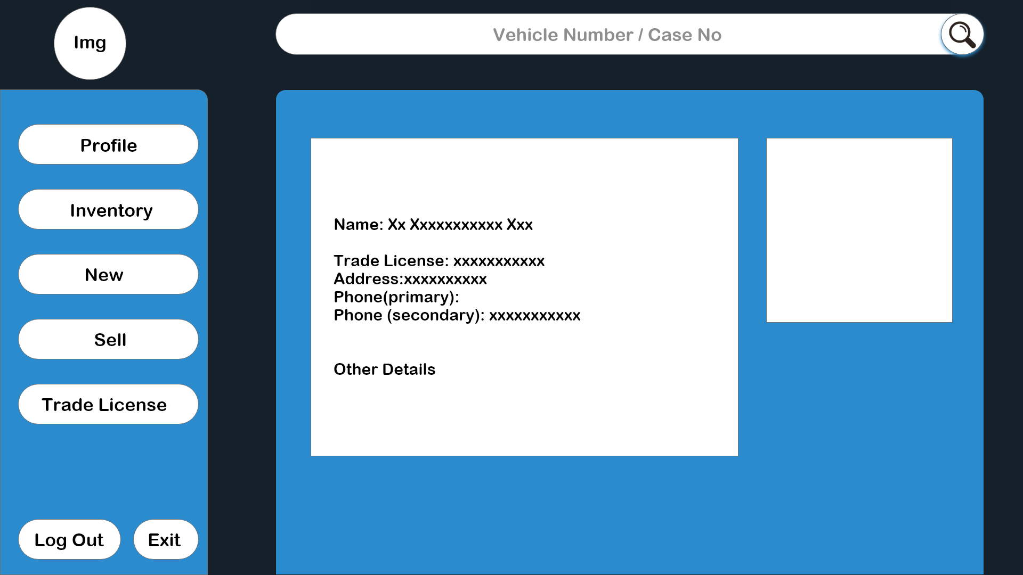

Details: Trade License Details

BRTA:

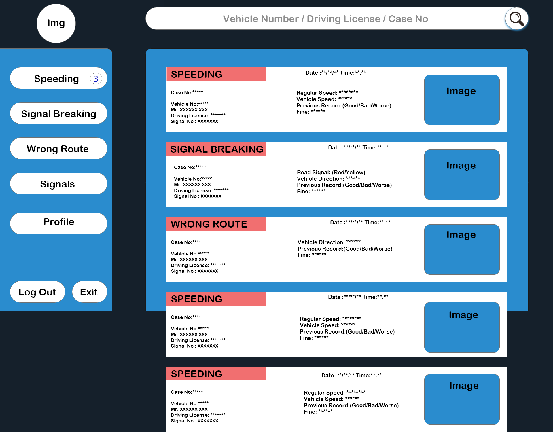

Details: News Feed

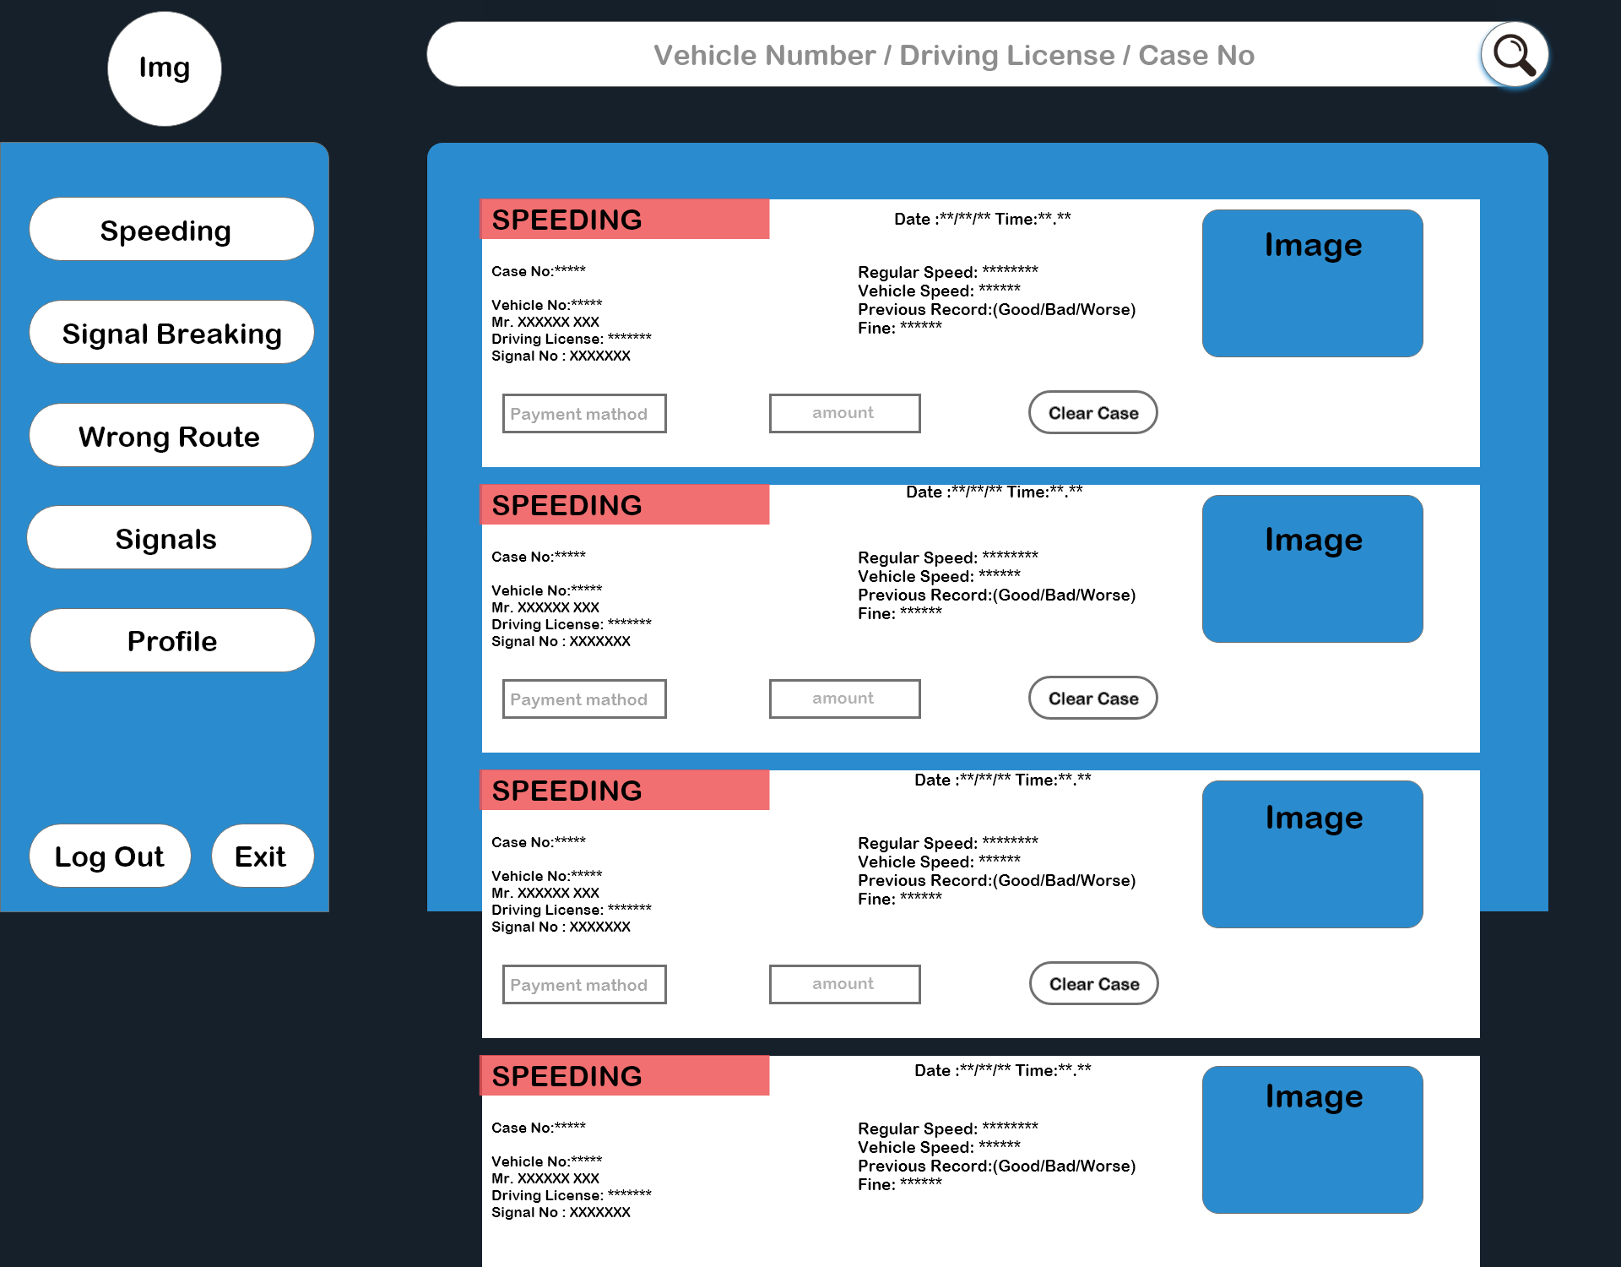

Details: Sub-Category

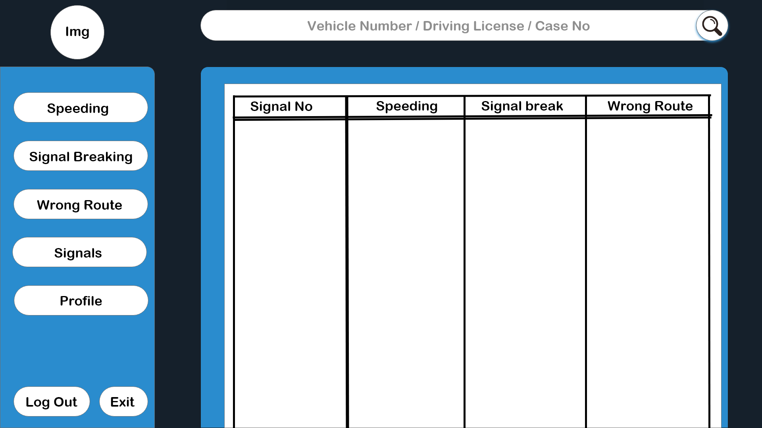

Details: Report for different Signals

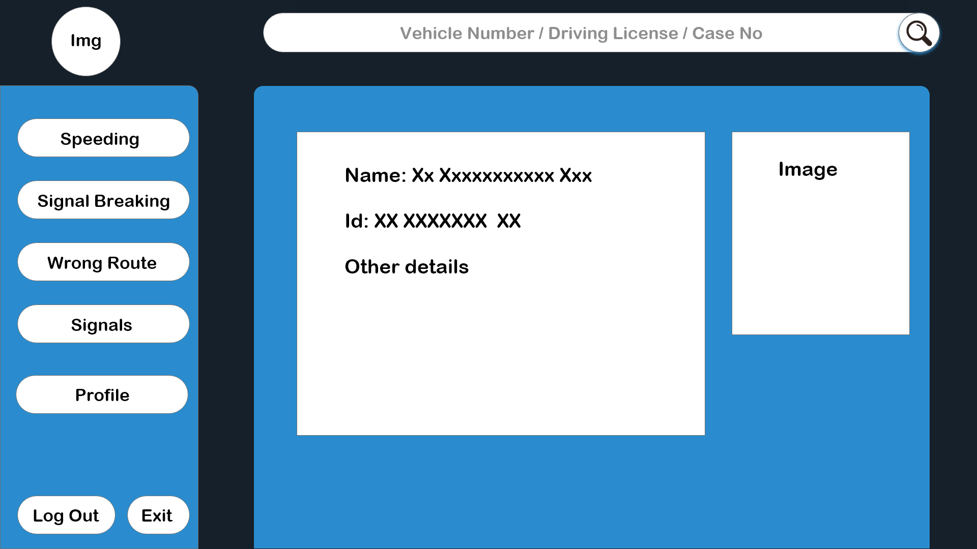

Details: User Profile

DRIVER:

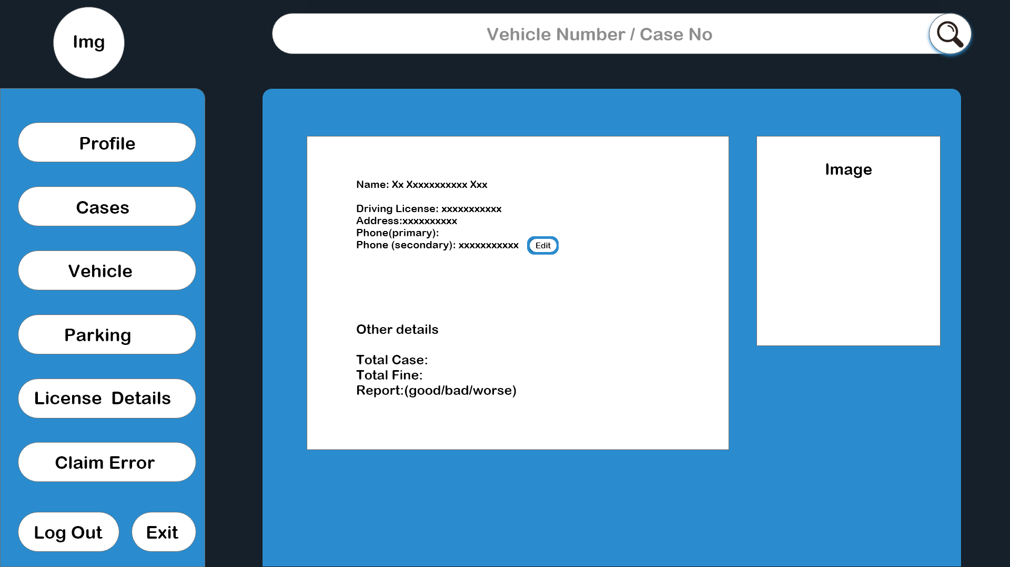

Details: Driver Profile

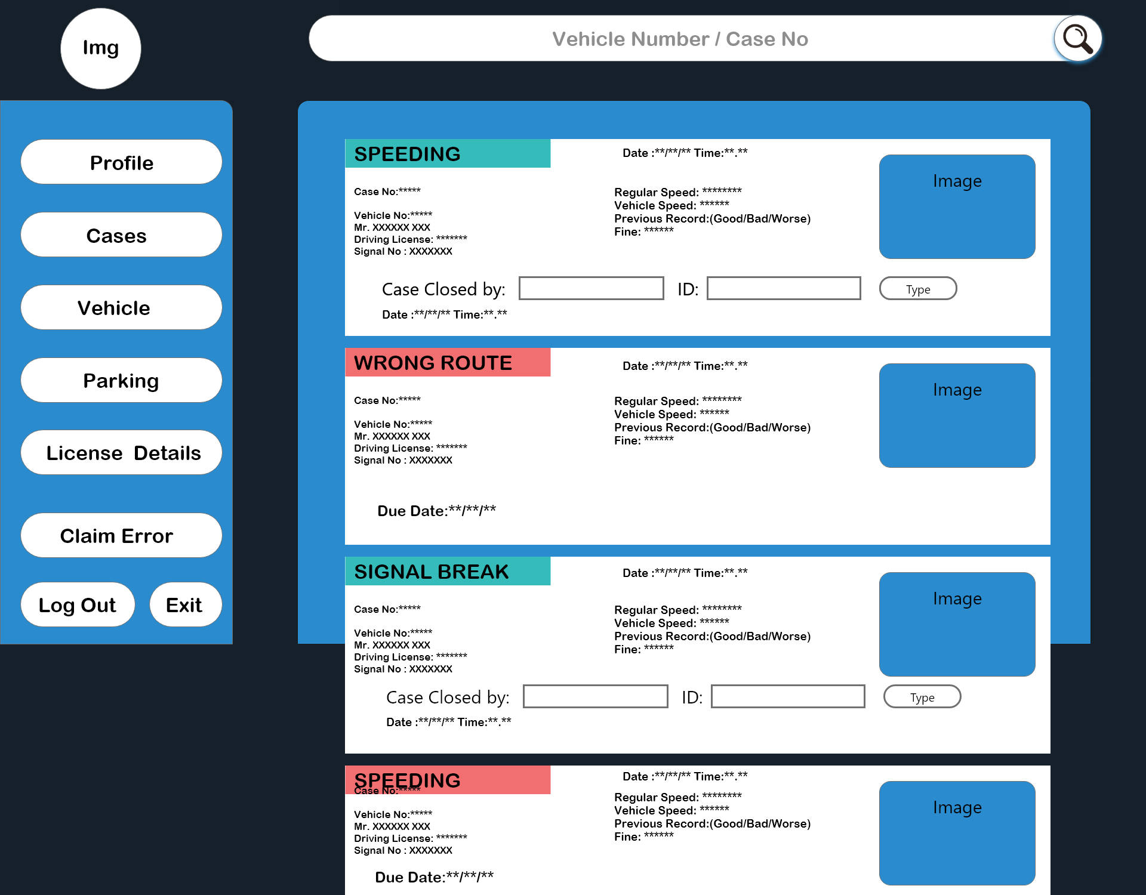

Details: Lifetime Case List

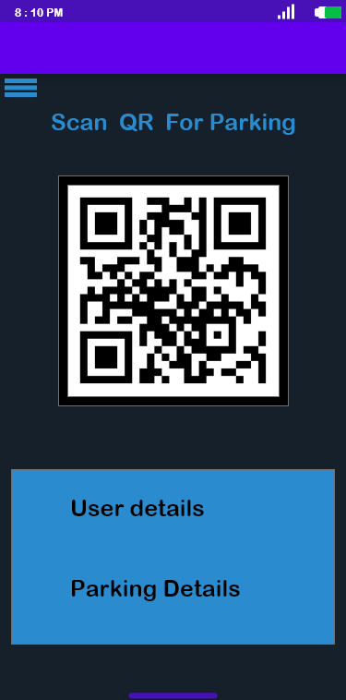

Details: parking Pass

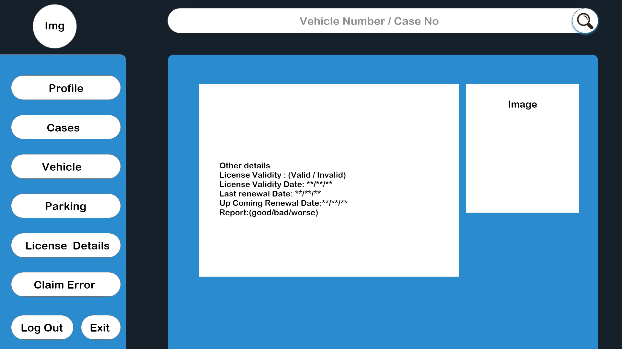

Details: License Details

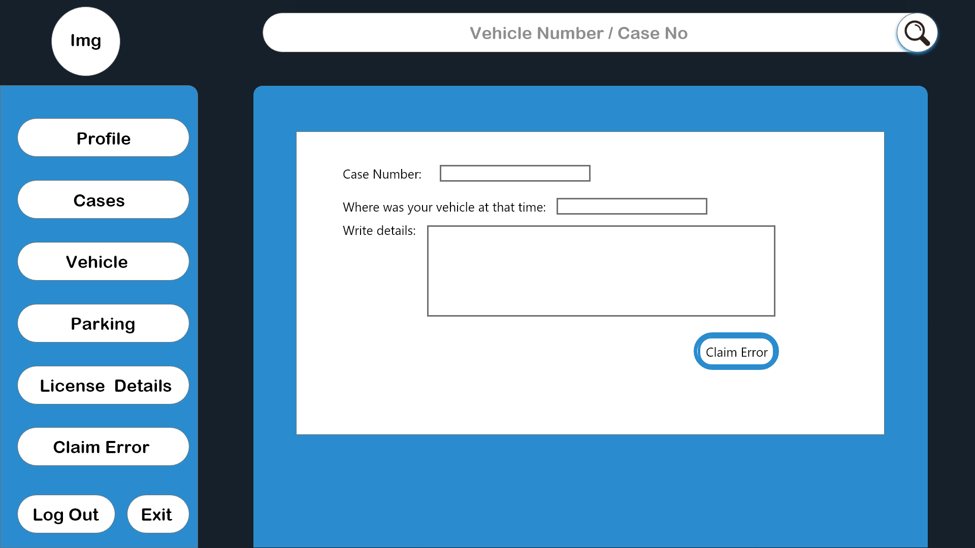

Details: Claim Error (case by mistake)

4.2: software interface: Operating system: windows, android, IOS, Microsoft word, adobe XD

4.3: Hardware interface: Not so many hardware used in this project. We used some simple hardware like Computer, Laptop, Mobile phone, Networking hardware etc. These devices are mainly used to check the feasibility the software.

4.4: Communication interface: github, trello, messenger, phone.

**4.4 Communication interface**

A. Control center

A control center is a center which monitors the traffic, SMS from GSM Modems and other activities which takes place in road.

B. Microcontroller

Microcontroller (also MCU or µC) is a functional computer system-on-a-chip. It contains a processor core, memory, and programmable input/output peripherals.

C. SMS

Short Message Service (SMS) is a communications protocol allowing the interchange of short text messages between mobile telephone devices.

D. GSM

(Global System for Mobile Communications: originally from Group Special Mobile) is the most popular standard for mobile phones in the world

E. AT Commands

AT commands are instructions used to control a modem. AT is the abbreviation of Attention.

F. Speed sensor

It is a type of device which can be activated if the speed of a vehicle goes above a Threshold Value

G. GPS

Global Positioning System: a navigational system involving satellites and computers that can determine the latitude and longitude of a receiver

**5. Quality Attributes**

5.1 Usability:

Manage your vehicle from home: A vehicle management system helps to manage vehicle, store all important data about vehicle type, fitness, routes, stations, driver-helper-officer details, vehicle base performance etc.

Ensure the best profitability: Using automation in every section of business. Such as asset tracking, manage daily activities, get automatic calculation of finance. That’s why to ensure the best profitability that should have an vehicle management system

Own a competent workforce: An automation system makes easy dealing of daily activities. One can specify your functionality as Admins, Super-admins Inventory manager & other employees activities. And have the system for monetising their performance to make them competent.

Manage inventory & expenses under control: Get all inventory record such as stock in hand, vehicle wise parts use report etc. We have designed a expense management system to take your inventory & expenses under control.

Take authentic decision: It includes an integrated system that helps you to keep all the information in one place. One can view all the data at a glance at any time, get instant report & can be able to take authentic decision.

Be the market leader of your industry: A computer based management system brings a supersonic speed to manage an organization, get report & ensure sustainable business growth. Having an automation system will help to be the market leader

5.2 Performance

It will give income and expenses report of all vehicles.

It will give vehicle wise parts uses report.

It will find out driver wise performance based information.

It will ensure best HRM. Such as: Drivers, Helpers, Other employees at a glance Report.

It will set an Alert Center. It will inform about all vehicle taxes, token, insurance, road permit, expiration date.

It will trace all over regular and irregular expenses.

It will apply an organized Inventory management system with regular income and expenses.

It has an automatic stock register.

It is an easy traceable stock and product system. Our system will manage best reporting system.

5.4 [others]

5.5 Cross-references

1) Engineering Advances, July 1997

2) Automation In Production - By Mikell P. Groover.

3) Salomon, Gavriel (1998). Individual and social aspects of learning:Review of research in education. Washington, D.C.: American Educational Research

Association. pp. 1–24.

4])McClanahan, Lorna (2014). "Training Using Technology in the Adult ESL Classroom". Journal of Adult Education. 43 (1): 22–27.

Perspective". CALICO Journal. 28 (2): 326–344. JSTOR calicojournal.28.2.326.

5) Murray, Liam; Triona Hourigan (2008). "Blogs for specific purposes:expressivist or socio-cognitivist". ReCall. 20 (1): 82–97. doi:10.1017/s0958344008000719.

6) Dieu, Barbara (2004). "Blogs for language learning". Essential Teacher. 1 (4): 26–30.

7)Thorne, Steven (2009). "'Community', semiotic flows, and mediated contribution to activity". Lang. Teach. 42 (1): 81–94. doi:10.1017/s0261444808005429.

8) Lam, Wan Shun Eva (2004). "Second language socialization in a bilingual chat room:global and local considerations". 8 (3)

**6. Data Requirements**

**6.1 Data dictionary -s**

|  |  |  |  |  |  |  |
| --- | --- | --- | --- | --- | --- | --- |
| Entity | | Attribute | Type/size | | validation | Key |
| user | | userID | Number (5) | | 10000-9999 | primary |
| user | | Forename | Text (10) | | Required |  |
| user | | Surname | Text (15) | | Required |  |
| user | | DOB | Date (8) | | Valid Date |  |
| Vehicle seller | | userID | Number (5) | | 10000-9999 | primary |
| Vehicle seller | | sellername | Text (15) | | Required |  |
| Vehicle owner | | OwnerID | Number (6) | | 9999-1111 | Primary |
| Vehicle owner | | Forename | Text (10) | | Required |  |
| Vehicle owner | | Surname | Text (15) | |  |  |
| Owner license | licenseID | | Number (13) | 11110-11111 | | Primary |
| Owner parking | parkingID | | Number (13) | 11110-11111 | | Primary |
| BRTA officer | officerID | | Number (15) | 999-100 | | Primary |
| BRTA officer | officername | | Text (12) | Required | |  |
| Parking manager | managerID | | Number (10) | 1000-9999 | | Primary |
| Parking manager | managername | | Text (12) | Required | |  |